The process of making a CPU chip with many transistors is known as semiconductor fabrication or semiconductor manufacturing. It involves a highly complex and precise series of steps, often referred to as a "fabrication process," that converts raw materials into a finished CPU chip.

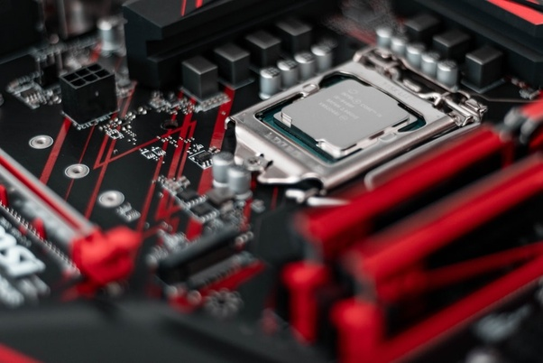

The basic building block of a CPU chip is a transistor, which is a tiny electronic device that can switch on and off to represent digital signals. Modern CPUs contain billions of transistors, and each transistor is only a few tens of nanometers in size.

The fabrication process involves several steps, including:

1. Crystal growth: The raw material, such as silicon, is purified and melted to form a crystal. The crystal is then cut into thin wafers, which are polished to a mirror-like finish.

2. Photolithography: A layer of photoresist is applied to the surface of the wafer, and a pattern is then projected onto the photoresist using a mask. The photoresist is exposed to light, which chemically changes its properties, allowing for the transfer of the pattern onto the wafer.

3. Etching: The wafer is then treated with chemicals to remove the parts that were not protected by the photoresist, leaving behind the desired pattern. This process is repeated several times to create multiple layers of transistors and interconnects.

4. Deposition: Thin layers of conductive and insulating materials are deposited onto the surface of the wafer using techniques such as sputtering, chemical vapor deposition, and atomic layer deposition.

5. Annealing: The wafer is heated to high temperatures to activate the implanted dopants and to improve the performance of the transistors.

6. Testing and packaging: The wafer is tested to ensure that the transistors and interconnects are functioning properly. Once the testing is complete, the wafer is cut into individual chips, which are packaged and tested again before being shipped to customers.

The entire fabrication process is highly automated and involves advanced equipment such as photolithography scanners, etching machines, deposition tools, and inspection systems. It also requires a highly skilled workforce with expertise in materials science, electrical engineering, and computer science.

In summary, the process of making a CPU chip with many transistors is a complex and highly precise series of steps that involve the conversion of raw materials into a finished product using a combination of advanced equipment and skilled labor.